Spedan’s Natural Trust

(The John Lewis Trust For The Advancement Of The Natural Sciences)

Chair’s Report 2025

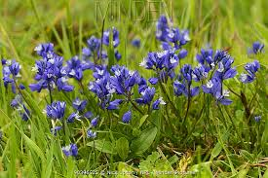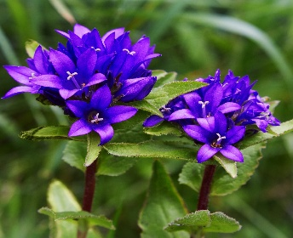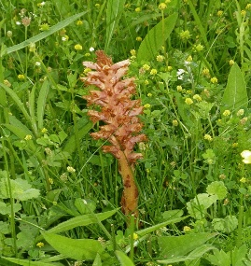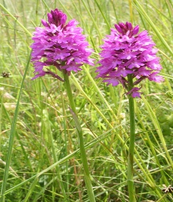

Wider overview
It’s an increasing pleasure to write these end of year reports as there is clear momentum in what the charity is doing. Maybe we will look back and think that we are only in the foot hills of greater things to come but for me the building blocks of a successful charity are getting stronger. I hope you feel the same. The covid years really did stop us in our tracks. The reports of biodiversity decline keep coming thick and fast which sadly makes our interest and dedication all the more important.
When I am asked, “what does success look like for our charity?” My answer is quite simple. It is fulfilling the objects of the deed which are ….. “advancing the cause of education in, and of promoting research into, and the study and knowledge of the natural sciences”…. This takes the shape of direct involvement in or support of species monitoring and habitat management. We also reach out to the local community by open days and our annual lecture evening. We are fortunate that the current agricultural thinking on the estate is almost entirely in harmony with biodiversity enhancement even to the point of having a dedicated partner for Estate biodiversity who is now an integral part of the Trust. The new buzz word is regenerative agriculture in which Waitrose is clearly taking a lead. This is most welcome.
People
There has been a definite surge in participation and skills led by Kath Hernon as Estate biodiversity office, Mike Meade Briggs enthusiasm for soils and bonfires and Kaylee and Rob Parks who are skilled monitors and have made an immediate impact as well as lowering our age profile. Mike Westby continues to excel in organising, IT and a number of things not all of us see, but I do so Thank you to all.
Juniper bank Scrape : This was a big deal for the Trust. Led by Kath this has been a collaborative project with The Trust, The Estate and Plantlife to boost natural regeneration of Juniper trees on the Juniper Bank reserve near the Leckford Golf Course. This project involved contractors creating a large chalk scrape in late August and in September. Volunteers harvested ripe Juniper berries for seed processing, and these were broadcasted onto the scrape. Thanks to Kath for the circa 10k of external funding and no cost to the trust!

Wild flower Assessment : The second project involved commissioning local ecologist Mike Wall to carry out botanical surveys over all of our chalk grassland parcels. Orabanche Bank had the most species recorded on it with 155 species identified and out of the Trust reserves surveyed it also scored the highest number of calcareous grassland indicator species as a percentage of the total. The stunning report ( gifted to the trust) offers observations about future habitat management which will need a response from the Trust. Thank you Mike.

Other Monitoring highlights : Glynne found one new moth species at Leckford this year - a nationally scarce marshland species called the Orange-rayed Pearl (Nascia cilialis). For only the second time in his experience the Marsh Oblique-barred, the Double Line, and the Cream-bordered Green Pea were recorded.

Kaylee recoded some rare species of bats, the Serotine Bat classed as 'Vulnerable' in the UK and the Leisler's Bat is classed as 'Near Threatened' in the UK. We are hoping to increase the number of bat boxes on the reserves and estate in 2026. The presence and health of bats tell us a lot about the state of the local environment, as they are top predators of common nocturnal insects and are sensitive to changes in land use practices.
Mike Mead-Briggs notes that the beetle survey work across the various Trust reserves has continued this year with new finds continuing to turn up on both the chalk banks and in the carrs. One beetle of particular note found on Fairview Bank was the weevil Sitona macularius, a single specimen being found amongst large numbers of the very similar and commonplace species Sitona lineatus (pea-leaf weevil). Next year there are plans to widen the beetle survey work to all parts of the farm estate and not just the reserves, to compare the current species diversity to older records available from the period 1945-1999. Another big deal!

LEAF Open Farm Sunday : This was supported by the Trustees and friends and created a lot of engagement with the public. We have decided to invest in a robust gazebo and relevant items so our stand can be more compelling and not blow away in the wind. Linda and will be testing a few out!!

Summer Open Day : Despite excellent planning by Mike Westby the Met office placed a yellow weather ( rain ) warning over the area and we felt bound to cancel. The rain never materialised!

Research

The University of Reading PhD student, ( Sirajum Munira ) co funded by the Natural Environment Research Council and the Trust made great progress using novel technologies to monitor biodiversity on the estate. The student employed drone – mounted cameras to map and characterise the 3D structure of hedgerows on the Estate, and deployed an automated insect camera store to record pollinators foraging on hedgerows. Emerging results were shared at the annual lecture.

Annual Lecture : This year we did a series of “in house” presentations on the work of the Trust. Andrew, Kath and Glynne all spoke eloquently but we all agreed the star of the evening was Sirajum Munira ( Phd Student ) with her description of, and enthusiasm for her work. We had 36 attendees. We will continue the direction of having a few talks of shorter duration and create more interactivity for the guests.

Finances : These remain in a strong position. I am aware we are spending less than our income partly due to unexpected funding from external sources. Thank you Alison Meade for maintaining the accounts each year.
Trust Co-ordinator : A big thank you to Linda for making this role the heartbeat of the charity. Linda devotes precious time and energy that makes the charity meetings and events run smoothy. Also her son, Morgan, quietly looks after our web site. We should be mindful of how we support both in keeping her role and the website interesting and effective.
The field centre : Thanks to Andrew for making the painting outside happen and decoration inside. There is more we can do to make the building fit for purpose and comfortable. Mike W is on this. Maybe one day we will get some comfy chairs!
Records During the year Glynne has sent to Linda the extensive records of his and others past monitoring. This is legendary work a lifetime in the making and we heartedly thank Glynne for this. We need to think about this resource and how we use it to compare future surveys
Summary and direction
In 2026 we need to resolve the difficult decisions of letting one or two reserves continue as inappropriately planted woodlands or fell the trees and return to fen. Decisions made decades ago have altered the nature of these reserves. Deciding what to do may be harder than getting the finance to do it so let’s resolve and make a plan in 2026
We are in the process of amending the governance document. This is our control document and I encourage all to read and comment up on it.
Finally the trust is about people. I make it my business to ensure we are as happy and fulfilled as possible. The guiding principle of The John Lewis Partnership set out by Spedan Lewis was that happiness is the basis for success. Thank you for being such an easy group to manage, for your comments and amazing skills and laughing at my bad jokes.
Have a good 2026

Alan

Who is who in 2025

Chair Alan Wilson
Co Ordinator Linda Anderson
Treasurer and Trustee Alison Meade
Trustee Glynne Evans
Trustee Prof Nick Sotherton
Trustee Dr Andrew Ferguson
Trustee Prof Simon Potts

Trustee Mike Westby
Friend Kaylee Parkes
Friend Kath Hernon

Friend Mike Meade Briggs

Friend Rob Parkes
Friend Rob West
Friend Susan Parish
